MS RESERVES OFFICERS E2 POSTING PREFERENCE FORM
Supporting guidance must be read prior to completion

No | Rank | Name (Surname & Inits) |  |  |  | Regt/Corps | Post Nominal Letters | Home Address
Work Tel |  |  | Mobile Tel |  | Home Tel |  | Date Available
Work E-Mail |  |  |  | Home E-Mail |  |  | Current Appointment

Commitment. Use this box to illustrate the amount of time you are able to commit. i.e. Maximum 90 days per year with 1 or 2 weekdays and consecutive weekends.

Location and Job Mobility. Use the box to describe your mobility in relation to your Job Preferences.

Career Aspirations. Your aspirations must be realistic and reflect the advice given to you by your career manager, whom you must consult prior to completing this form.

E2 Job Preferences. Indicate in order of preference.
Pref | Jobs List Ser No | JSN | Appointment Title and PID | Avail | Supporting Comments | Commitment
1st
2nd
3rd
4th
5th
6th

GUIDANCE FOR COMPLETING A RESERVE PPP

Commitment box

- Be clear and specific on what time can be committed. For example:
- “I can do 1 day per working week and 2 weekends per month.”
- “I can commit to 60 days per year; with 30 of these available for weekday duties.”
- “I can do 3 weekends per month and a summer 4 week block period.”

- Show current and/or recent Reserve commitment levels. For example:
- “In my current XX job I monthly commit to five weekdays and two weekends.”
- “I work part-time/self-employed and can commit to 3 working days every week.”
- “In the last training year I committed to 60 RSDs: 36 comprised mid-week working.”

- Indicate any ‘added value’ that underpins Reserve commitment. For example:
- “I have a supportive employer who offers X days/weeks per year for Reserve training.”

- Suggestion for Commitment box completion -
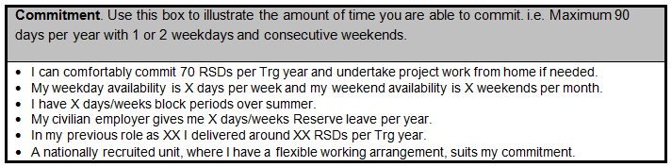
Supportive employer
Stating commitment that suits
Current/previous commitment
Block periods of availability/flexibility
Clear commitment levels

Location and Job Mobility

- Clearly link Location and Job Mobility to Job Preferences box. Show you have carefully considered the location of each Reserve job applied for and have planned how to get there for duty.

- Show accessible transport means thus demonstrating the ability to commute to your next job.

- Indicate evidence of ‘travel flexibility’ to add value to your PPP. For example:
- “In my current SO2 job I undertake a Southport to York return journey five times per month on average.”
- “For 2.5 yrs as SO2 Ops at 11 Sig & WM Bde I commuted weekly from Cornwall to Telford.”

- Suggestion for Location and Job Mobility box completion -
Travel shown to each selected job in PPP ‘Preferences’ box
Access to travel means

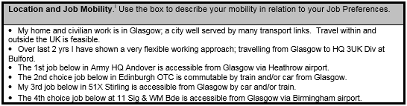

Evidence/history of travel

Career Aspirations

- Speak with your CM before completing the PPP. Your CM will know what roles are coming up, what the competition is, what your realistic options are and what is achievable for you.

- Show ‘near’, ‘middle’ and ‘far’ career thinking (i.e.: next 2-3 yrs, the following 4-6 yrs and later 6+ yrs.). This displays evidence of your career planning even if it does not exactly work out.

- Add supporting remarks and substance to your career vision. For example:
- “I want to do an SO2 TRG OPS role in order to develop myself for future work in the Training Intelligence & Operations Centre.”
- “My civilian skill set and experience, working as an HR Manager for Tesco, are closely aligned with future employment in G1 and CM.”

- Suggestion for Career Aspirations box completion -
Bulleted - ‘near’, ‘middle’ & ‘far’ plan
Evidence of civilian role adding potential value
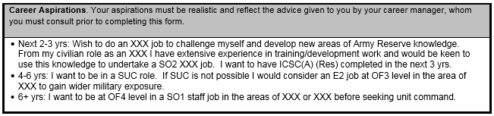

Job Preferences

- Give full job details as per Jobs’ List (i.e.: Ser No, JSN, appointment title and PID.) and use preference order (i.e.: 1st choice job, 2nd choice job, etc.).

- State correct availability date to take up new role – this is the target fill date from the Jobs’ List. Do not repeat your ‘date available’ (agreed with your CoC or FAD) from box 1 in the PPP.

- Give supporting comments which are relevant, factual and concise. 200 characters is the specified limit. Refer to qualifications, experience and suitability for the job selected. Comments should be aligned with the job spec.

- Give supporting comments in a readable, succinct and logical style. Bullet points are good.

- Show commitment level commensurate with the job requirements.

- Suggestion for Job Preferences box completion -
Commitment as per job spec
Avail as per Job List

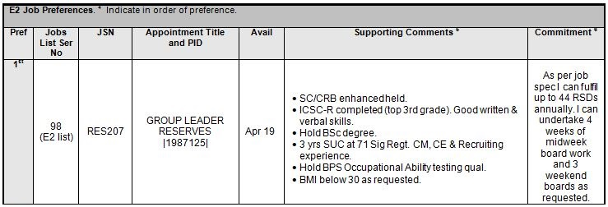

Full details from Job List
- Supporting comments – concise, aligned with role and job spec
- 199 chars shown here (not incl spaces)

